Submission Guidelines for xCoAx 2027: Papers
Anonymise Name Surname¹, Name Surname²
¹ Anonymise Author affiliation, Town, Country
Anonymise Author email
² Anonymise Author affiliation, Town, Country
Anonymise Author email
Abstract. Summarise the contents of the submission in 100–200 words.
Keywords: Provide a minimum of 4 and a maximum of 8, separated by commas.

1 Introduction
Papers should have between 3,000 and 6,000 words (excluding references). Submissions should be delivered as PDF files, while the final documents for publication should be delivered in Word format; both must be formatted using the styles provided in this template.
Initial submissions must be fully anonymised for the reviewing process. Mentions of artworks, exhibits, or performances may include links to multimedia files where the authors can be seen working/performing, but names and identifications should be avoided as much as possible.
When preparing the final document to be published in the proceedings, authors’ names should not include academic titles or descriptions. Names of multiple authors should be separated by commas. Affiliations should appear below the author’s name or list of names and include town (if it is not already part of the affiliation itself) and country. Email addresses should appear directly below the affiliations. Multiple affiliations should be marked with superscript numbers and presented on separate lines, as shown in this template.

2 Document Structure and Formatting
Format all text using the styles provided in this template so that the text can be easily edited for publishing in the online proceedings. Please do not leave empty lines between paragraphs. Body text should be formatted in Normal style (10 pt; aligned left; line spacing: single; space after: 10 pt).
All papers should be written in English. Please make sure that there is consistency throughout the text when following American, British, or any other English norms. Quotations from foreign language texts should be translated into English. Where necessary, the original text may be quoted in footnotes.

2.1 Title
The title of the paper should be formatted using the Title style and set in title case. Separate the title from the subtitle using a colon (:) instead of an en or em dash. When including names of artworks/projects in titles of papers, use italics instead of quotation marks or All Caps. Please use italics consistently throughout the text and make clear whether capitalisation is part of the title of works/projects (e.g., xCoAx).

2.2 Headings
Compose all first and second level headings in title case using the appropriate styles (Heading 1 and Heading 2), as demonstrated in the table below. Number all first and second level headings including Introduction and Conclusion, but do not number third and fourth level headings. The References section heading should be formatted in Heading 1, but unnumbered.

Table 1. Level styles, typeset examples, font size and formatting for headings
Level: style | Example | Formatting
First: Heading 1  (title case, numbered) | 1 First Level | 16 pt, bold;  align left; line spacing: single; space before: 20 pt; space after: 10 pt; Keep with next; Keep lines together.
Second: Heading 2  (title case, numbered) | 1.1 Second Level Heading | 12 pt, bold;  align left; line spacing: single; space before: 20 pt; space after: 10 pt; Keep with next; Keep lines together.
Third: Heading 3  (sentence case, unnumbered) | Third level heading | 11 pt, bold;  align left; line spacing exactly 10 pt; space before: 10 pt; space after: 10 pt; Keep with next; Keep lines together.
Fourth: Heading 4  (sentence case, unnumbered) | Fourth level heading | 11 pt, italic;  align left; line spacing exactly 10 pt; space before: 10 pt; space after: 10 pt; Keep with next; Keep lines together.

2.3 Notes
Superscript note markers should appear either directly after the word, phrase, or sentence to which they refer or immediately following the punctuation mark, where applicable. Notes should be used sparingly and formatted as footnotes (not endnotes). Number all footnotes consecutively, and do not include footnotes in the abstract.

3 Figures and Captions
Figures can be placed directly in the document, but they should always be referred to by their figure number and numbered consecutively. All images should be prepared with a minimum width of 1,000 px to ensure that they can be zoomed in the published proceedings. Images should be composed inline in the Word file; however, the final versions for publication should also be provided as higher-resolution attachments in PNG, TIF, or JPG format.
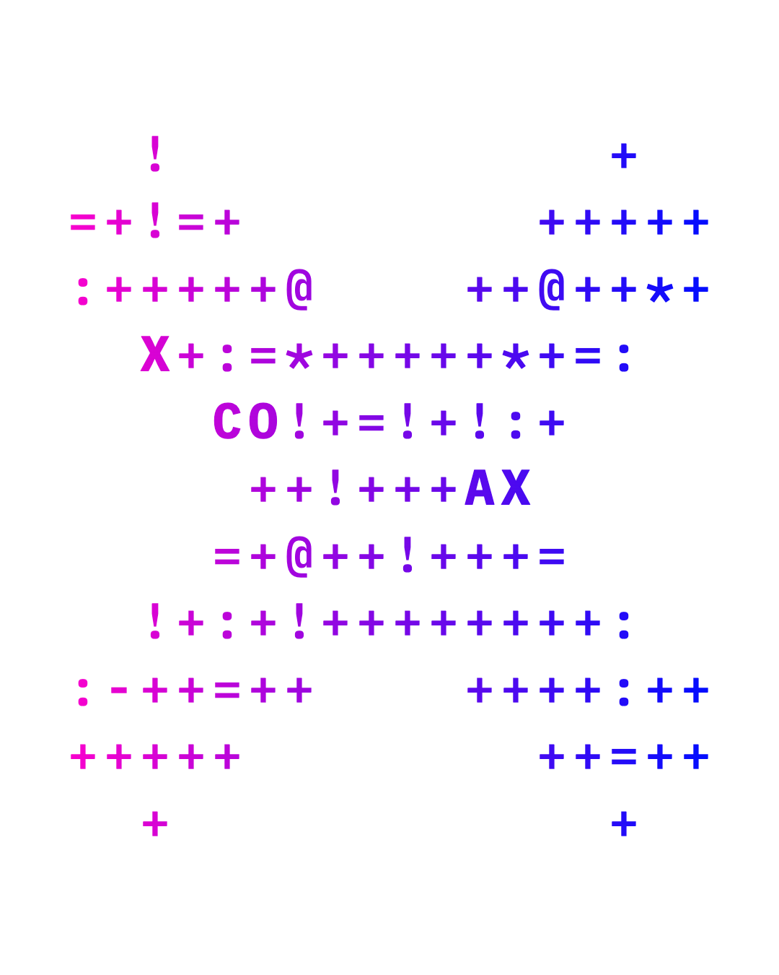

Fig. 1. xCoAx 2027 logo.
Media assets (such as audio, video) can be represented in the final version of the text for publication as a screenshot or static image. The corresponding caption should include a URL pointing to the online version of the asset.
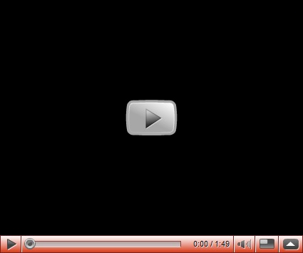

Fig. 2. A video asset (http://www.vimeo.com)

3.1 Figure and Table Captions
All figure and table captions should be numbered sequentially and include a reference to the source whenever necessary. Figure captions must be composed below the figures, while table captions should be placed above the table, both using the same Table + Figure Caption style (10 pt; centred; line spacing exactly 10 pt; space before 10 pt; space after 10 pt; Keep lines together).

3.2 Program Code
Program commands in the text should be set in the appropriate Code style. Use the Code caption style for notes after the code:
size(400,400);
background(loadImage("mt-fuji.jpg"));
PImage img = loadImage("dandelions.jpg");
image(img, 0, 0);
blend(img, 0, 0, 132, 400, 268, 0, 132, 400, LIGHTEST);

Example of a pixel-blend function from https://processing.org/reference/blend_.html

4 Quotations, Citations and References
Quotations must be carefully transcribed and accurate. All in-text quotations must be identified by quotation marks and followed by the corresponding citation. Citations in the text should be labelled with (Author Year) or (Author Year, page) following the Chicago Manual of Style conventions, as shown in the Author-Date sample citations, of the Chicago-Style Citation Quick Guide (Chicago Manual of Style Online 2024).
Format short quotations with double quotation marks and inline, such as “the computer is not fundamentally a wire or a pathway but an engine” (Murray 1997, 72). Format longer quotations as indented paragraphs, without quotation marks, using the Blockquote style, as shown below:
Here’s a new one for the psychopathology manual: possiplexia, being overwhelmed by possibilities—either freezing in the face of them, like people I know, or trying to grab them all, like me. (Nelson 2010)
The reference list should include only sources cited in the text. References should be organised alphabetically by author and chronologically. All references must be written using the Latin alphabet. Where applicable, indicate the original language at the end of the title, following its translation, e.g., (in Chinese) or (in Greek). The section heading should be References, not Bibliography, and should use the Heading 1 style without numbering.

5 Additional Information
The submission of the final version of the paper constitutes authorisation to publish it in the xCoAx 2027 proceedings. Should you have any questions, please contact info@xcoax.org.
AI Use Statement: For review purposes, all submissions must include a statement disclosing whether and how generative AI was used in preparing the manuscript, identifying the tools used and their purposes. If deemed relevant, the final document for publication may also include a statement on the use of generative AI in the work presented.
Acknowledgements. If necessary, acknowledgements should be placed at the end of the text in the final document for publication, immediately prior to the references, with a bold, run-in heading.

References
Chicago Manual of Style Online. 2024. “Author-Date: Sample Citations.” Citation Quick Guide. Accessed October 4, 2026. https://www.chicagomanualofstyle.org/tools_citationguide/citation-guide-2.html.
Lindquist, Benjamin. 2023. “The Art of Text-to-Speech.” Critical Inquiry 50 (2): 225–51. https://doi.org/10.1086/727651.
Murray, Janet. 1997. Hamlet on the Holodeck: The Future of Narrative in Cyberspace. The MIT Press.
Nelson, Theodor. 2010. Possiplex: Movies, Intellect, Creative Control, My Computer Life and the Fight for Civilization. Mindful Press.
(Revised October 2026)

When using title case, capitalise the first letter of all major words, i.e. nouns, pronouns, adjectives, verbs, adverbs, subordinate conjunctions, and use lowercase for articles (a, an, the), coordinating conjunctions, prepositions, and the ‘to’ in an infinitive.
This is an example of a footnote in Footnote Text style.

